User Manual

Year: _2017__ Semester: _Spring__ Team: _12__ Project:__Guitutar__________________

Creation Date: ___4/12/17_____________ Last Modified: April 12, 2017

Author: __Jennifer Isaza_______________ Email: _jisaza@purdue.edu___________

Assignment Evaluation:

|  |  |  |  |  |
| --- | --- | --- | --- | --- |
| **Item** | **Score (0-5)** | **Weight** | **Points** | **Notes** |
| **Assignment-Specific Items** | | | | |
| **Product Description** | 4 | x1 | 4 | Technical detail needed |
| **Product Illustration** | 4 | x2 | 8 | More pretty pictures!!! |
| **Setup Instructions** | 5 | x3 | 15 |  |
| **Usage Instructions** | 5 | x3 | 15 |  |
| **Troubleshooting Instructions** | 5 | x3 | 15 |  |
| **Writing-Specific Items** | | | | |
| **Spelling and Grammar** | 5 | x2 | 10 |  |
| **Formatting and Citations** | 5 | x1 | 5 |  |
| **Figures and Graphs** | 5 | x2 | 10 |  |
| **Technical Writing Style** | 5 | x3 | 15 |  |
| **Total Score** | 97/100 | | |  |

5: Excellent 4: Good 3: Acceptable 2: Poor 1: Very Poor 0: Not attempted

Comments:

This manual is quite useful and I only have a couple things to suggest changing. Excellent work!

1. Product Description

The guitar is one of the most common instruments that new players try to pick up and learn. Just like any instrument, the guitar comes with its own challenges that can leave players feeling frustrated and stagnant in their progress. Guitutar acts as a tool to motivate players and help them enjoy the learning process of guitar. The installation process is simple: unstring guitar, unscrew neck and amplifier jack to remove, screw in Guitutar neck and new amplifier jack, attach power box, and restring guitar. Guitutar then becomes a part of your electric guitar by providing LED fingerings for chords and songs in either a learning mode or a full playback mode.

1. Product Illustrations

Figure 1: Example Drawing of Guitutar Attachment

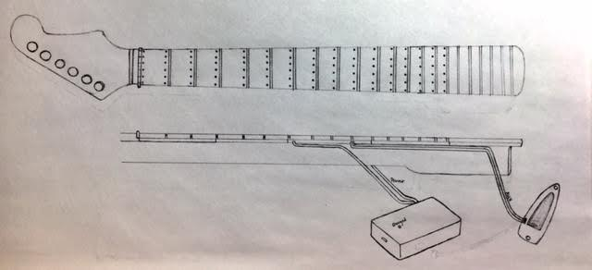

Figure 2: Finished Guitutar, Front



Figure 3: Finished Guitutar, Back



1. Setup Instructions

*Setting Up Guitutar:*

1. Remove the neck and input jack plate of your electric guitar
2. Replace neck with Guitutar’s LED neck and replace input jack with Guitutar’s input jack
3. Run the input jack’s wires along the back of your electric guitar (or wherever is the most comfortable) and plug wires into aux input on power box
4. Restring guitar with your strings of choice
5. Charge Guitutar with a mini USB through the power box

*Charging Guitutar:*

1. Insert the small end of a mini USB cable into the power box
2. Plug the other end of the mini USB cable into a power supply
3. Allow Guitutar to charge until the LED on the side of the power box turns green
4. This process should be repeated with every use of Guitutar and can be done while playing

*Connecting to Guitutar:*

1. Download the “Guitutar” app to your Android device
2. Open Bluetooth settings on your Android device
3. Click on “Guitutar” under the Bluetooth available devices in order to connect your device to Guitutar
4. Verify that your Guitutar is connected through the app
5. Usage Instructions

*Using Guitutar App:*

1. Open “Guitutar” app once connected through Bluetooth to Guitutar
2. Choose either “Learning Mode” or “Full Playback Mode”

*Using Learning Mode:*

1. Select song you want to play
2. Press “start” to begin playing song
3. The LED fingerings will light up along with the chords or fingerings of the song you have selected to play
4. Place your fingers on the correct note-string combinations and strum in order to progress to the next chord or note
5. Press “end” to finish song

*Using Full Playback Mode:*

1. Select song you want to play
2. Press “start” to begin playing song
3. The LED fingerings will light up along with the chords or notes of the song you have selected to play
4. The LED progressions will not wait for you to play the correct notes and will go in time with the selected song
5. Press “end” to finish song

** Note to user: The playing of open strings will be indicated by illuminated LEDs near the nut of the guitar neck

1. Troubleshooting Instructions

|  |  |
| --- | --- |
| **Problem** | **Potential Solutions** |
| Strum not being recognized | * May need to strum harder * Check that your aux wires are securely plugged into the power box * Check if Guitutar is powered on * Check that Guitutar is fully charged |
| Guitutar is not lighting up | * Check that Guitutar is fully charged * Check Bluetooth connection * Check if Guitutar is powered on |
| Guitutar is not connecting to Bluetooth | * Check that Guitutar is fully charged * Check if Guitutar is powered on * Check if you are connected to other devices * Turn off and on Bluetooth |